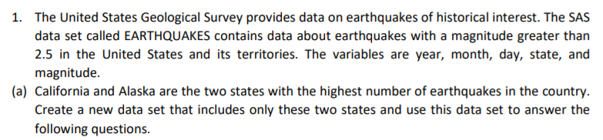

Code:

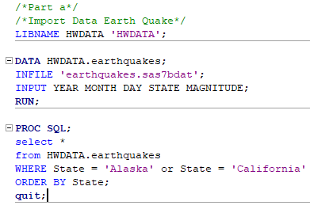

Output:

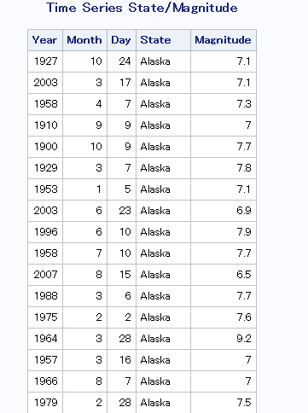

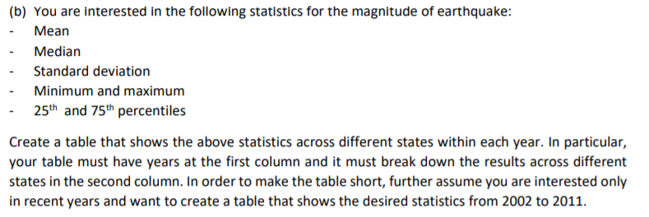

Code:

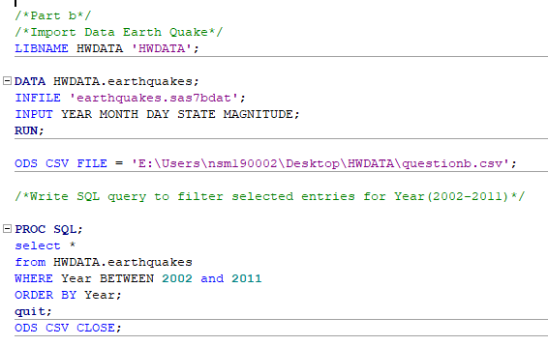

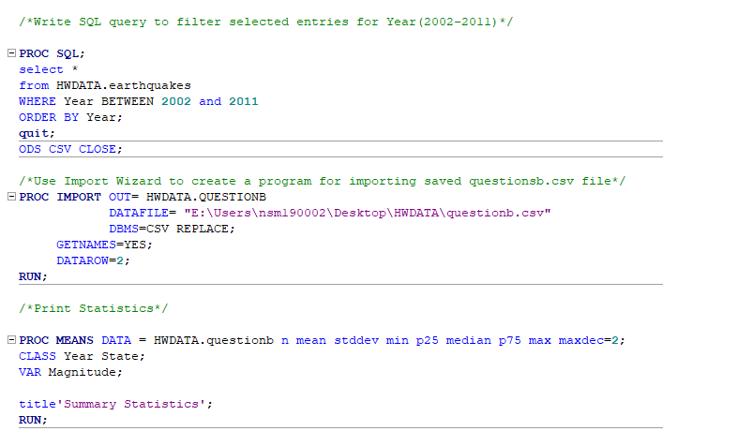

Output:

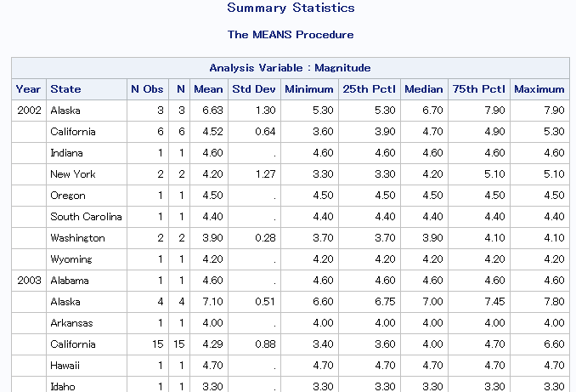



Code:

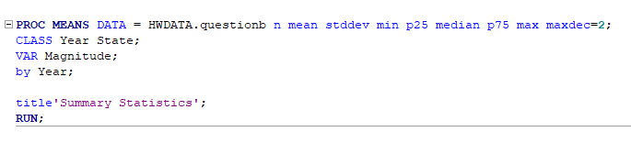

Output:

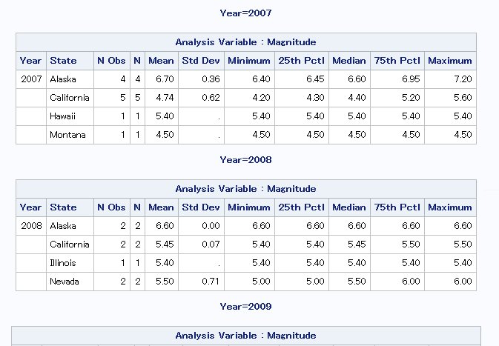



Code:

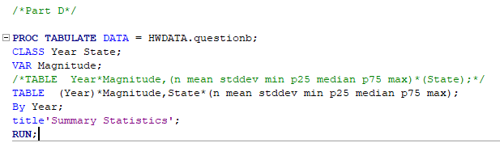

Output:

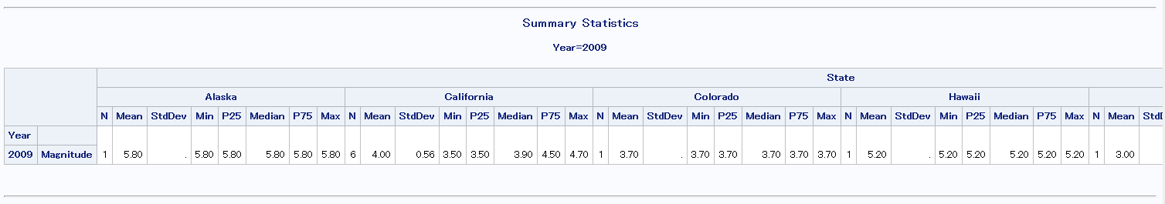

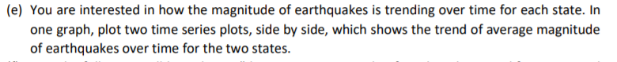

Code:

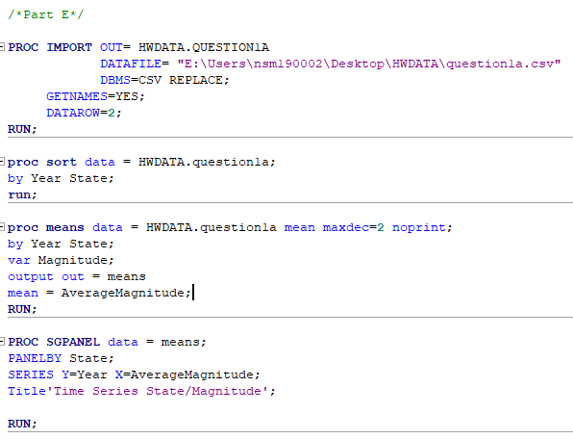

Output:

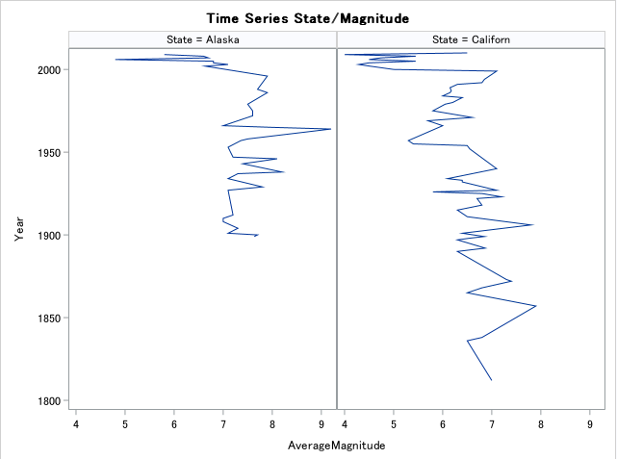



Code:

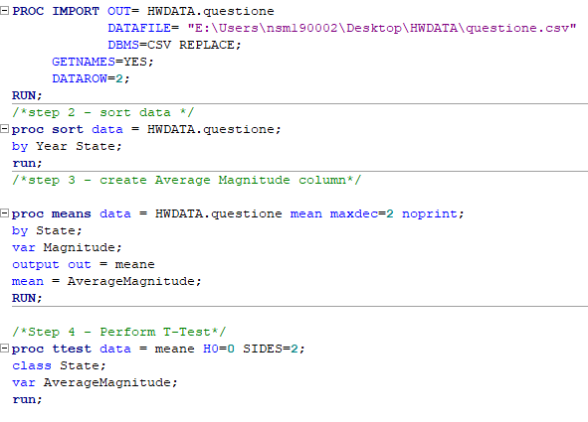

Output:

Answer: Since P-value here is 0.0009 which is less than 0.05, so we reject the Null Hypothesis

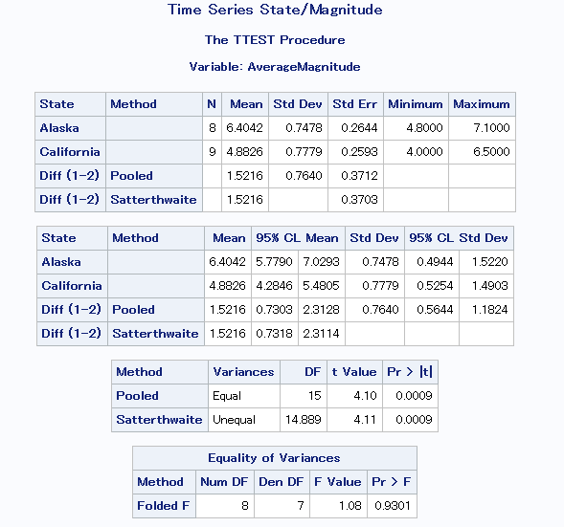

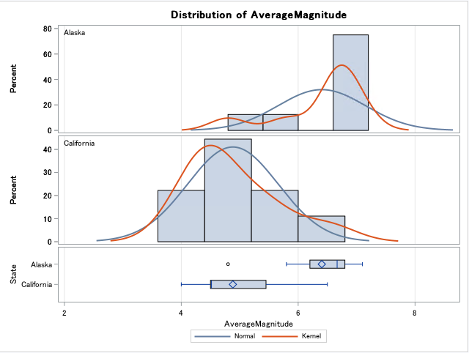

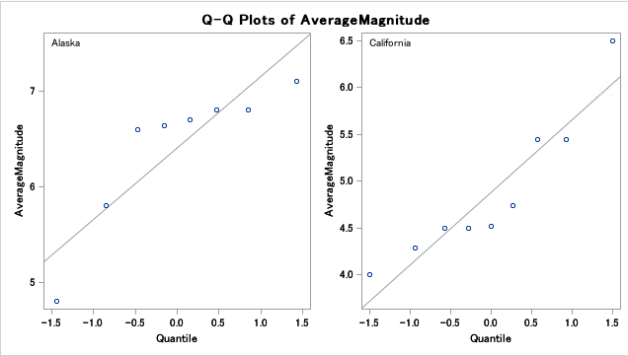

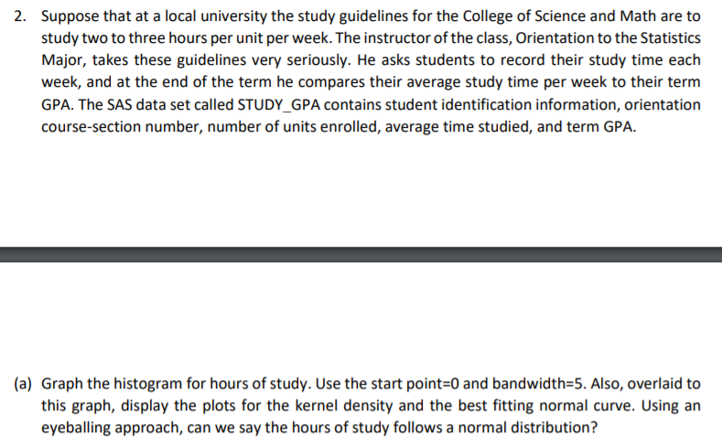

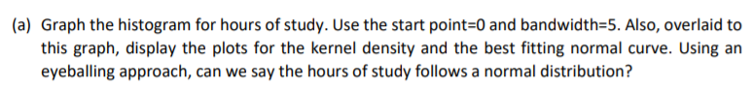

Code:

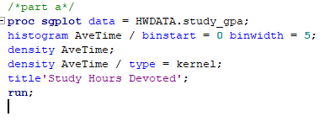

Output:

Kernel density line shows that graph is almost near normal.

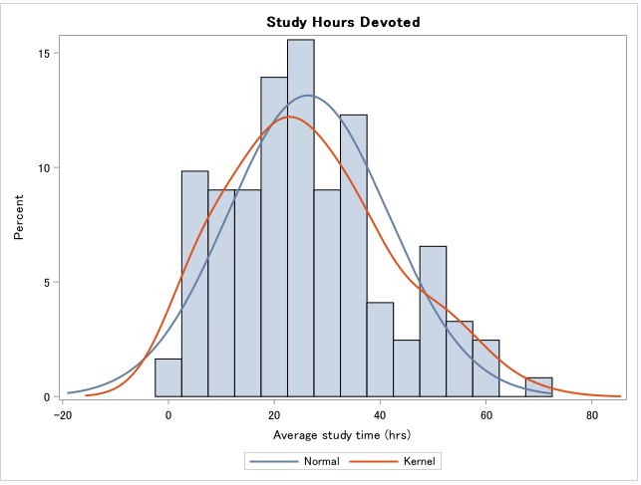

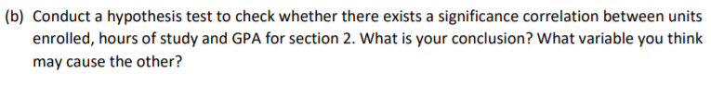

Code:

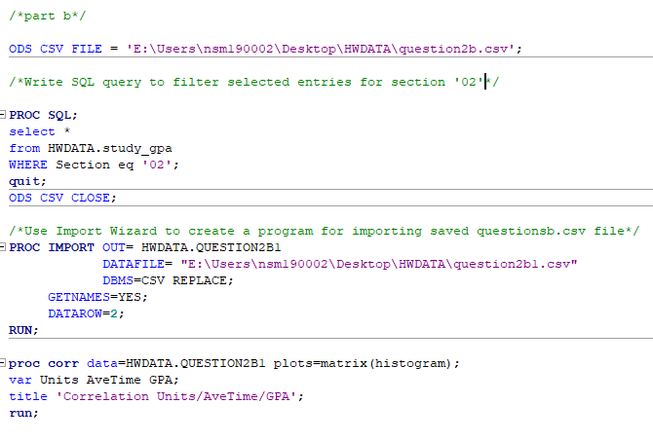

Output:

As we can see from the summary here:

1. For one unit increase in Units, there is 0.34 unit increase in Average Time
2. For One unit increase in Average Time, there is 0.10 units increase in GPA
3. For one unit increase in Units, there is 0.01 units decrease in GPA

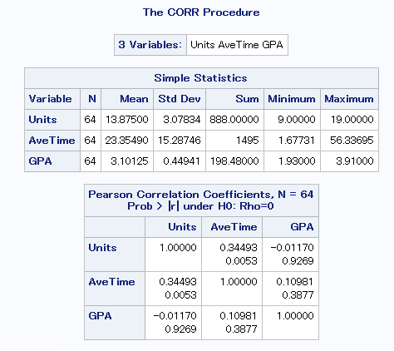

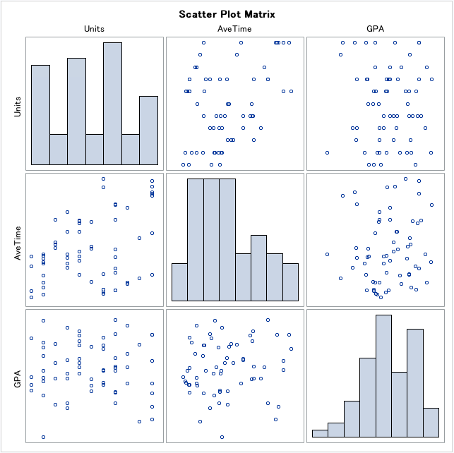

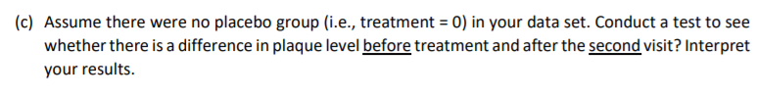

Code:

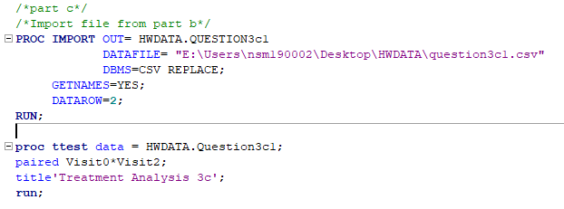

Output:

**For this experiment we only considered dataset with no control group (Placebo)**

**Hypothesis:**

H0: V0(No treatment) – V2(After 2nd Visit in Treatment) = 0

H1: V0 – V2 NE 0

As we can see that P-value is less than 0.0001, which makes it significant enough to reject the Null.

We can safely say that there has been improved in patient’s health after taking Vitamin E drug.

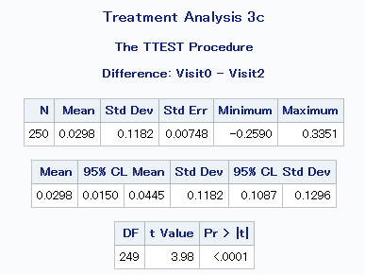

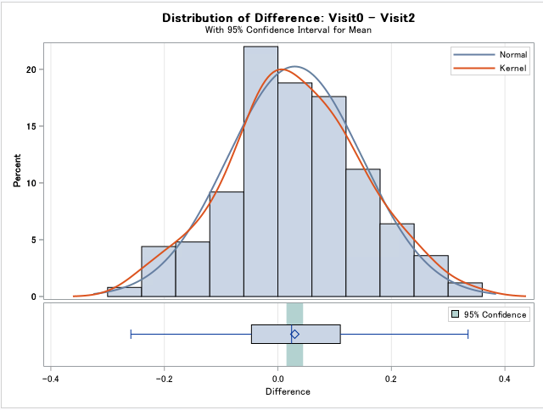

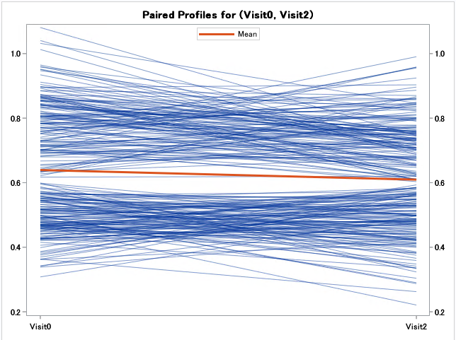

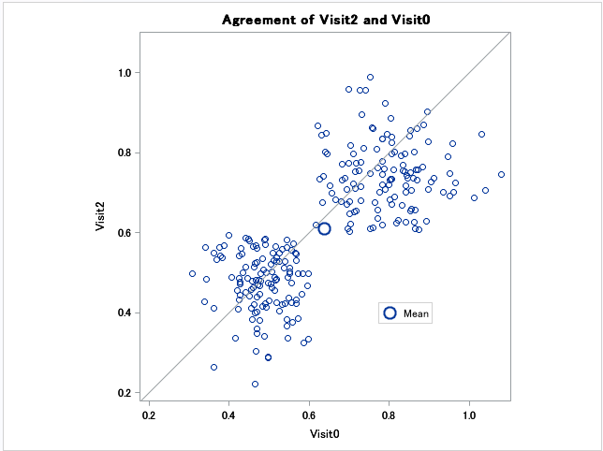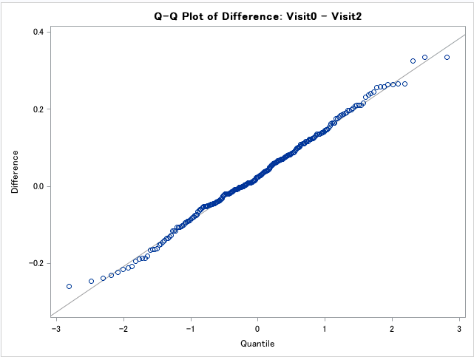

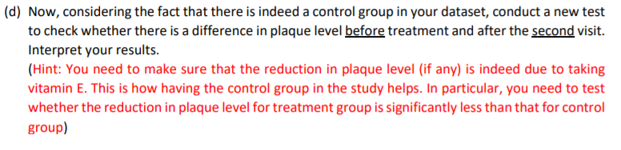

Code:

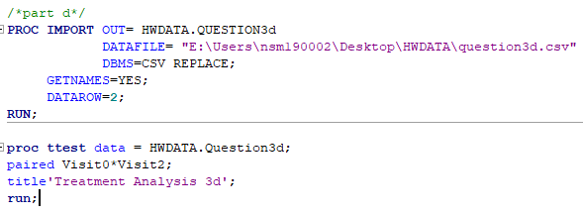

Output:

Hypothesis

H0: V0 – V2 = 0

H1: V0 – V2 NE 0

As we can see that P-value is 0.03 which is less than alpha = 0.05. So, we do not reject the Null and it means that there is no subsequent effect in change in health of people by taking Placebo Drug. This makes sense to check the effectiveness of the drug.

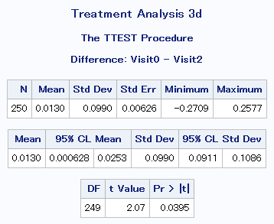

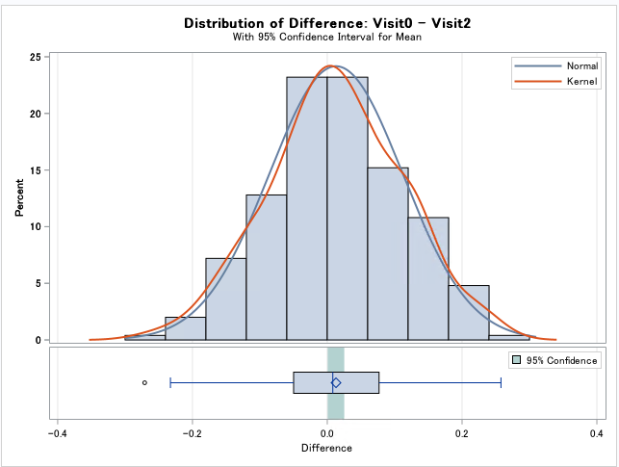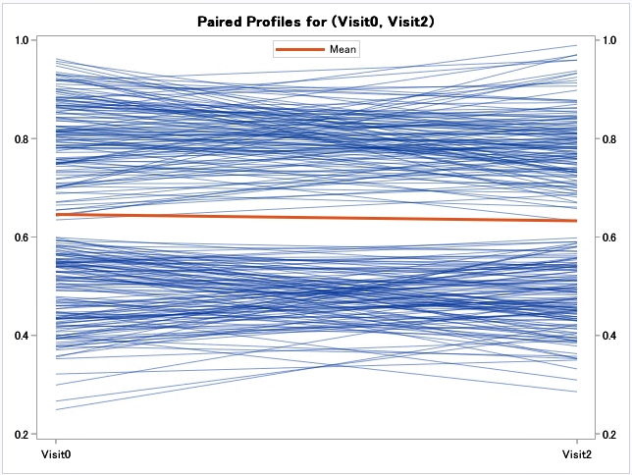

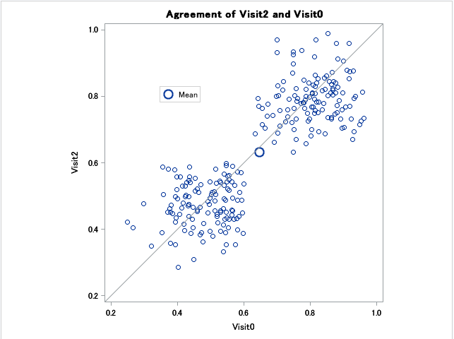

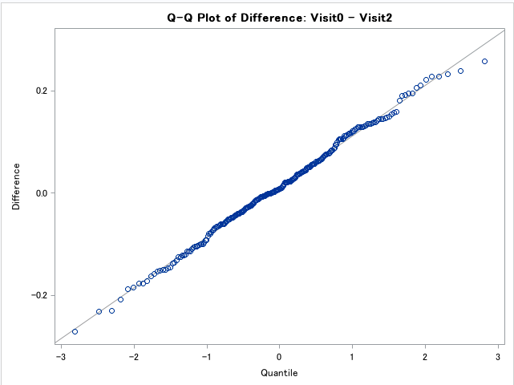

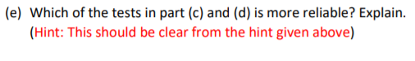

**Answer:** I think testing for T-Test in both the cases made sense to me since we wanted to check the effectiveness of the drug and indeed it did prove that by taking Vitamin E drug, the wellness of patient is improved.

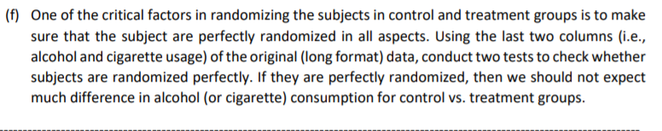

Code:

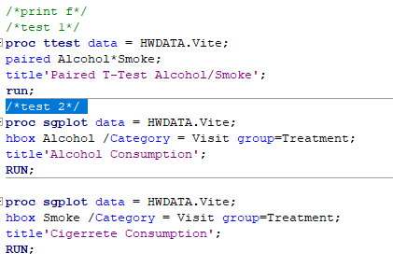

Output:

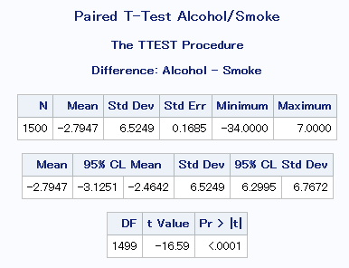

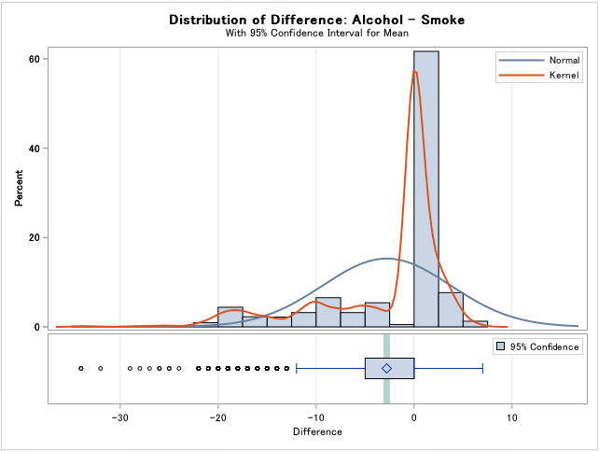

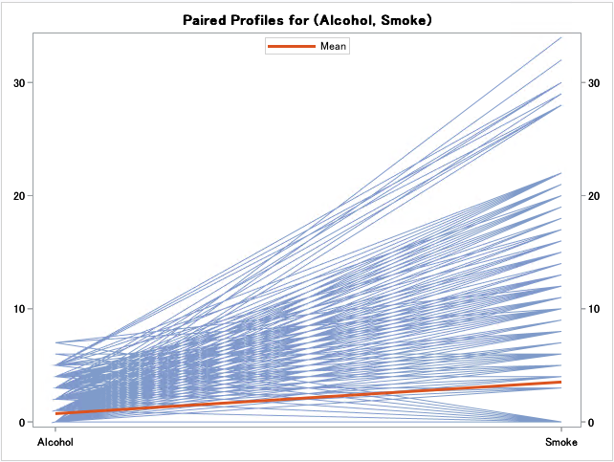

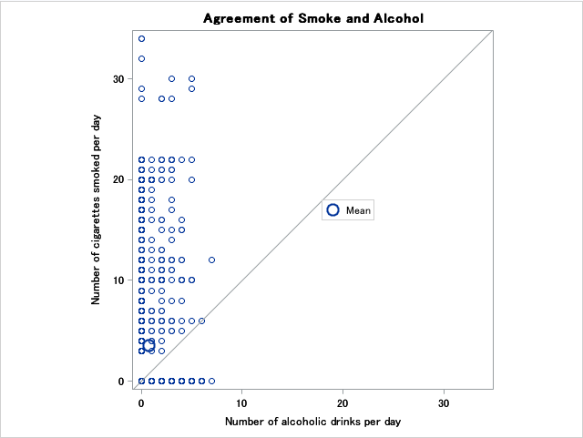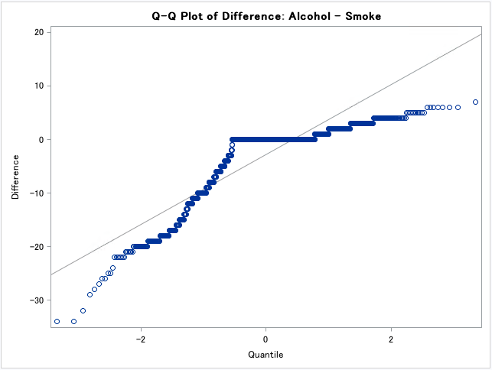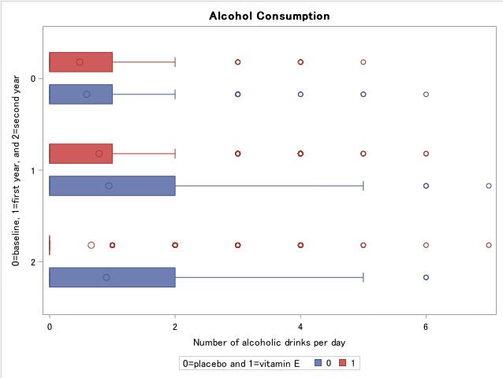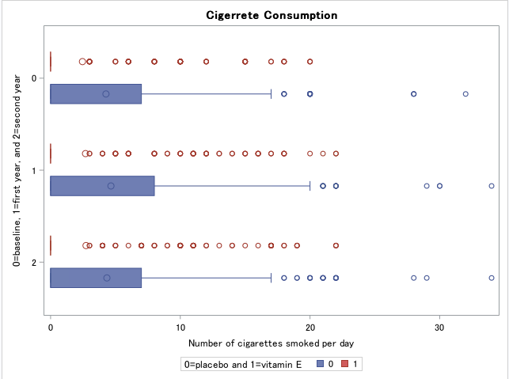

**Acknowledgements:**

1. <https://stats.idre.ucla.edu/sas/modules/how-to-reshape-data-long-to-wide-using-proc-transpose/>
2. <https://support.sas.com/resources/papers/proceedings/proceedings/sugi30/257-30.pdf>
3. <https://documentation.sas.com/?docsetId=sqlproc&docsetTarget=n1e51p1t33ruyyn1iyzqonf3r0cm.htm&docsetVersion=9.4&locale=en#n149ioasupdfb0n1vs31jz24j38f>
4. <https://www.sas.com/content/dam/SAS/sv_se/doc/other1/Exporting-SAS-Data-Sets-and-Creating-ODS-reports-140219.pdf>
5. <https://documentation.sas.com/?docsetId=odsug&docsetTarget=p0oxrbinw6fjuwn1x23qam6dntyd.htm&docsetVersion=9.4&locale=en>
6. <https://www.sas.com/content/dam/SAS/en_ca/User%20Group%20Presentations/Calgary-User-Group/Yankovsky-ExploringProcTtest-Apr2015.pdf>
7. <https://examples.yourdictionary.com/examples-of-control-groups.html>
8. <https://www.youtube.com/watch?v=FLQ_ittU1gc>
9. <https://www.quora.com/How-can-you-test-that-your-random-assignment-was-truly-random>